Exploring Climate Change Indicators
Spring 2022 Seminar
01:450:413/ 16:450:523 (3 credits)
Tuesday 5-6 (3:50-6:50pm)
Lucy Stone Hall-B120, LIV
Prof. Dave Robinson

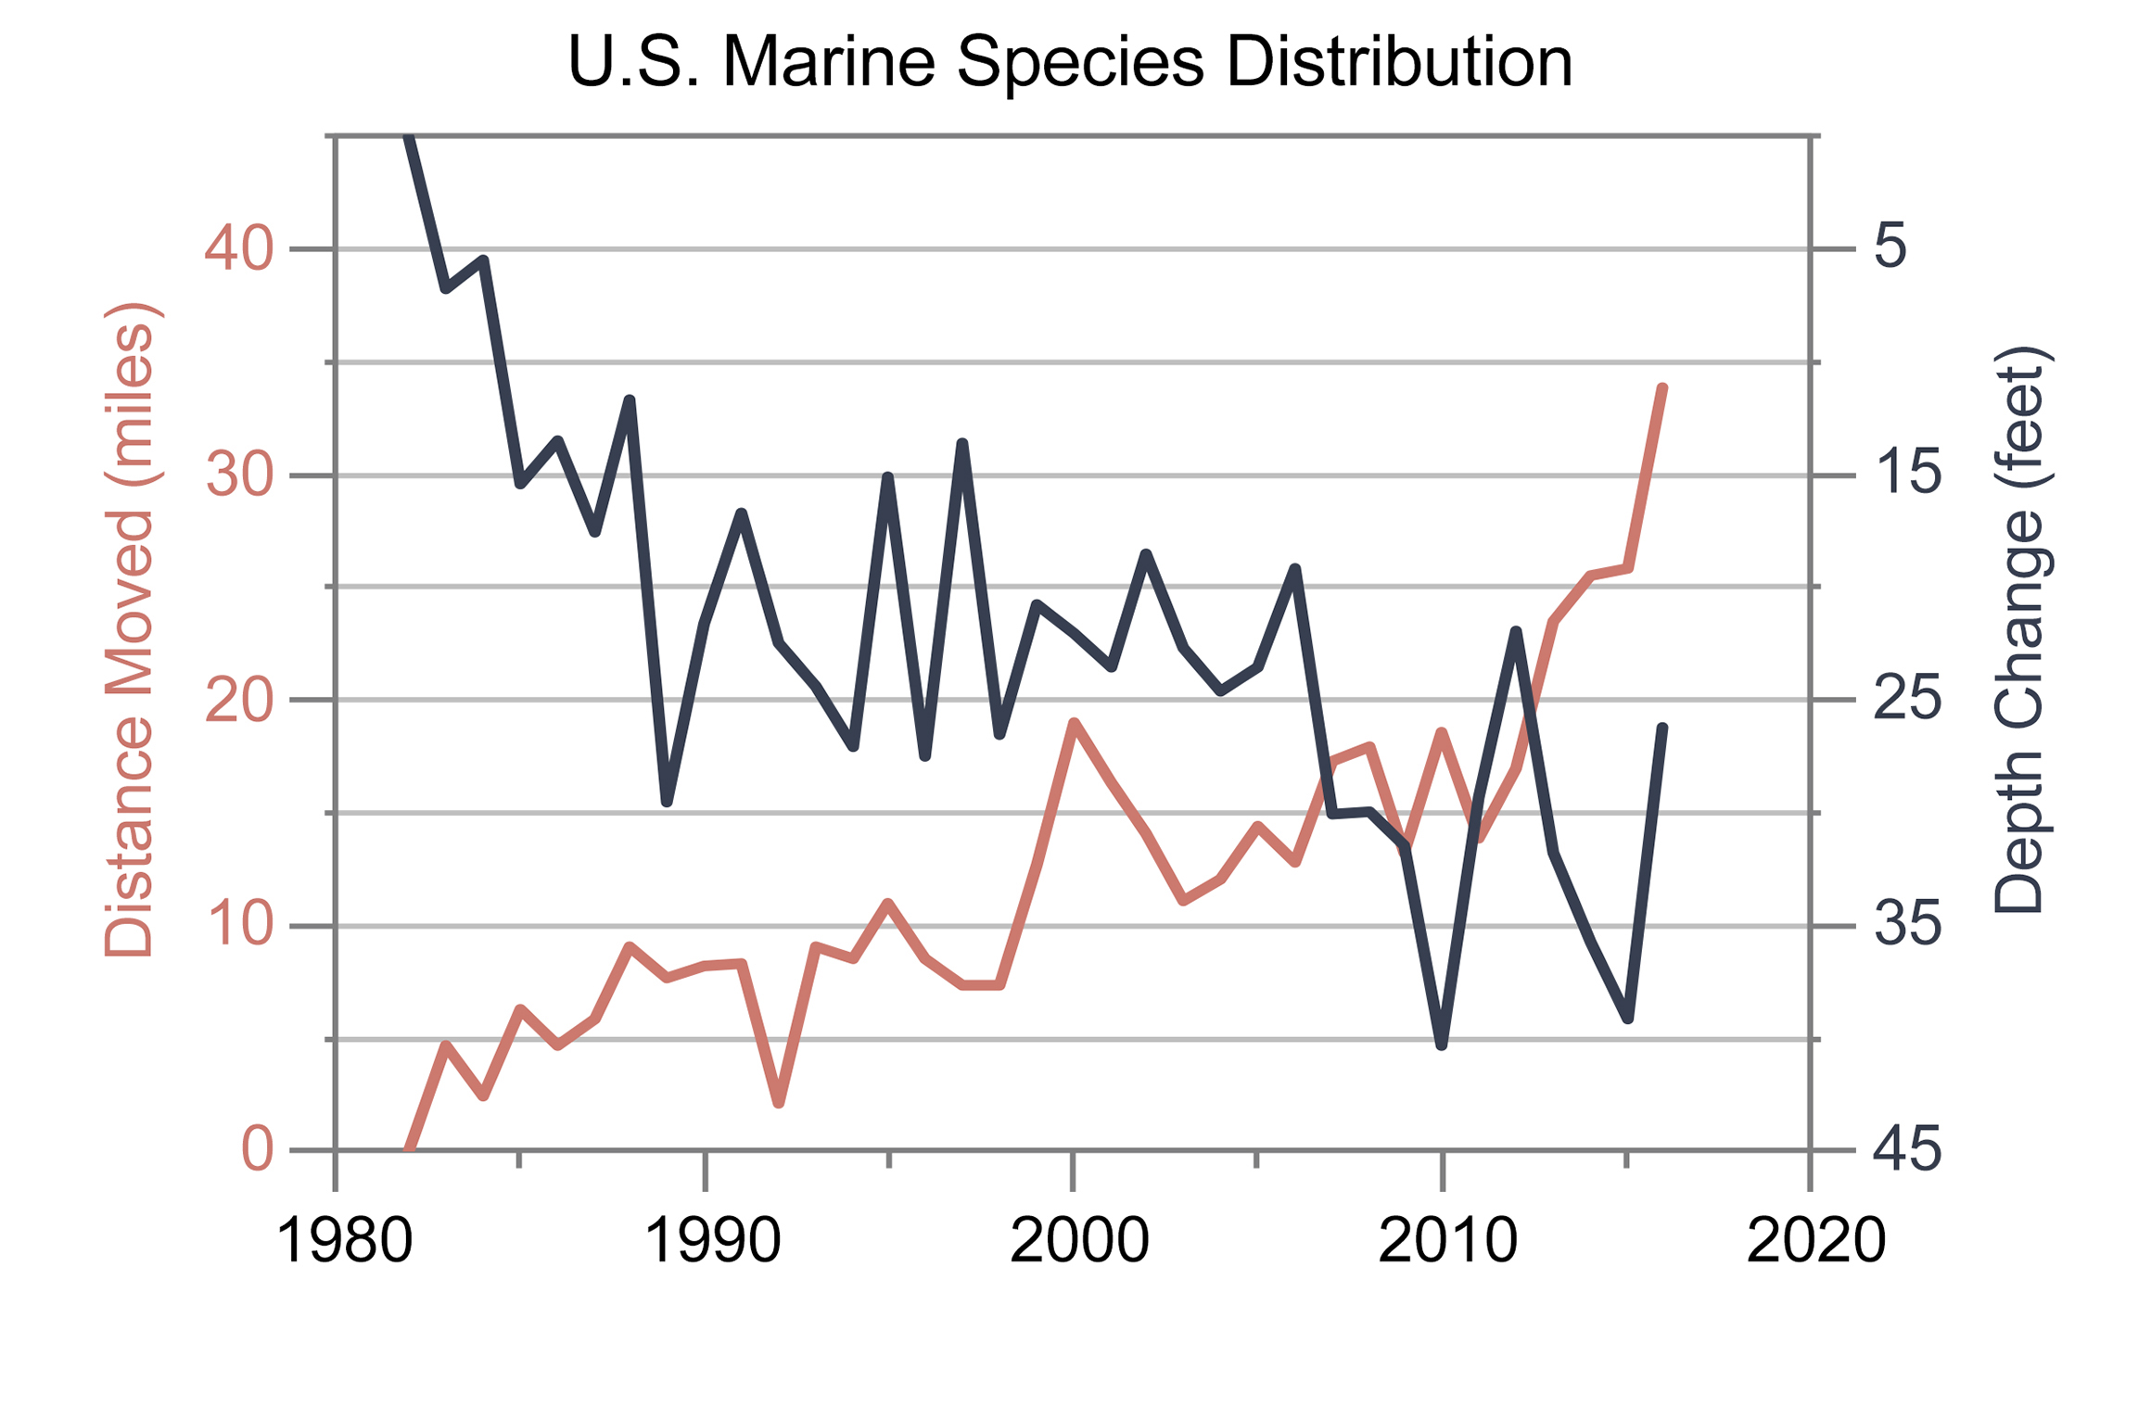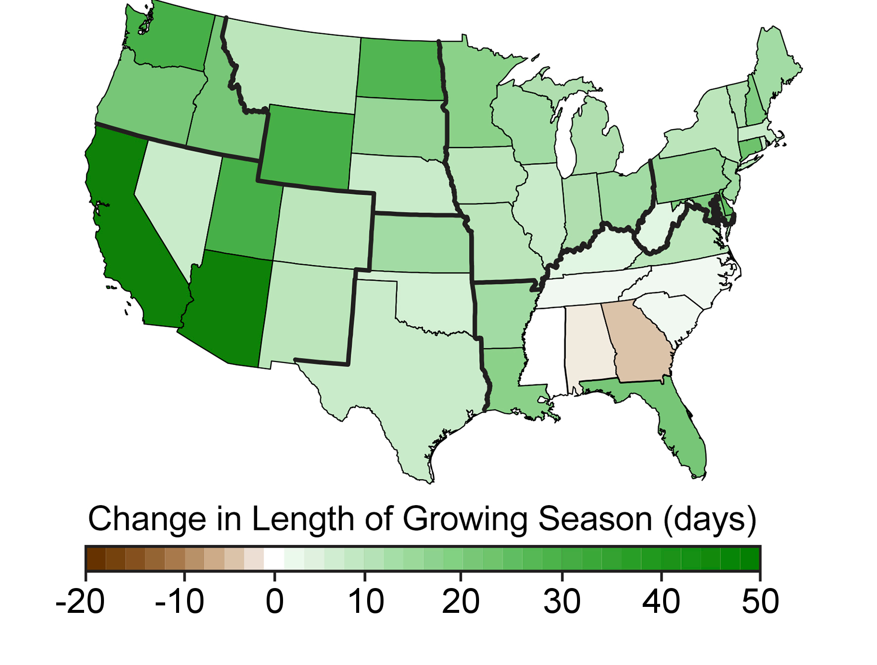
Marine species distribution Change in growing season
This seminar will explore Earth’s changing climate by examining indicators that are used to express the rate and magnitude at which key aspects of the climate system are varying. Indicators include a multitude of environmental variables across the globe, such as those put forth by the US Global Change Research Program https://www.globalchange.gov/browse/indicators and NASA https://climate.nasa.gov/evidence/

The seminar will meet Tuesdays from 3:50-6:50 in B120 Lucy Stone Hall (Livingston campus) and is available to undergraduates (by permission only), and to any interested graduate student. For further information and for receiving undergrad permission, contact Prof. Robinson at david.robinson@rutgers.edu.

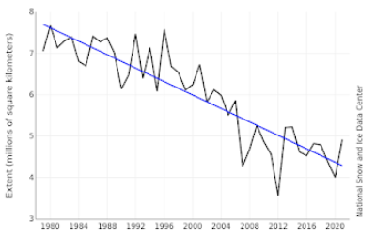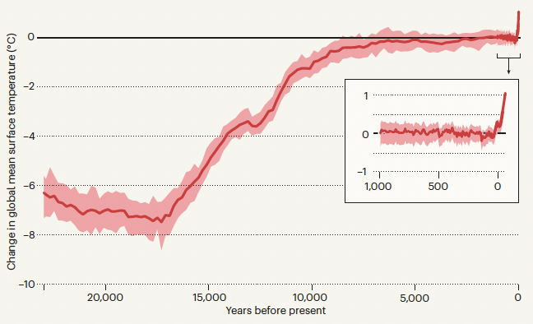
September Arctic sea ice extent Global temperatures past 24,000 yrs.

