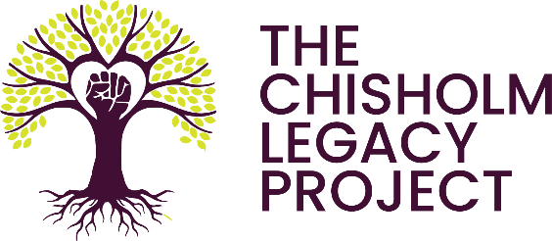

Request for Proposals
Climate Justice Resource Hub

Objective
The Chisholm Legacy Project is seeking a qualitative researcher to facilitate fact finding to guide the development process of the Climate Justice Resource Hub.

The Climate Justice Resource Hub will serve as a repository of information that will holistically support frontline climate justice activists. We seek to provide activists with scientific and technical tools, organizing and media resources, cultural and emotional support, and more.

Organization Background
The Chisholm Legacy Project serves to connect Black communities on the frontlines of climate change with the resources to transform their communities using the Just Transition Framework. The organization is named in honor of Shirley Chisholm, the first African American woman to serve in US Congress and a paragon of gender and racial justice advocacy.

The Project supports frontline organizers by linking movements and mainstream actors with the necessary tools to advance systematic change centered in equity and justice. In particular, the Chisholm Legacy Project seeks to support Black women in leadership roles across the climate movement through capacity building, mentoring, and emotional support. As part of these broader efforts, the Chisholm Legacy Project is building a resource connector to meet the holistic needs of frontline activists. This resource connector will be called the Climate Justice Resource Hub.

The Chisholm Legacy Project is seeking to understand how the resource hub should be designed and structured to ensure accessibility and inclusivity for frontline activists. Our questions center on both layout and graphic design, as well as informational taxonomies and hierarchies. Our goal is to create a Resource Hub that is intuitive and accessible to the diverse actors within the Climate Justice Movement.

Project Description
The Chisholm Legacy Project is seeking a qualitative researcher to support the development of the Resource Hub. The researcher will be responsible for developing and executing a methodology to adequately address the research questions outlined by the Chisholm Legacy Project.

Our Research Questions are:
- What information taxonomies and hierarchies are most accessible to frontline climate justice activists?
- How should the Climate Justice Resource Hub be designed to ensure ease of navigation for all users, including those with disabilities or low technical literacy?
- What resources have activists searched for and not been able to easily find?

The Chisholm Legacy project is open to a diverse set of methodologies to answer these questions. However, respondents to this RFP should make a clear case for why their proposed methodology will produce rich and detailed answers to the questions above. To protect the health of the activists and communities that the Chisholm Legacy Project serves, all research will need to be conducted remotely. Proposed methodologies should clearly address this requirement.

The Chisholm Legacy Project will support the qualitative researcher by providing technical expertise to the development of any discussion guides used for participant discussions. Recruitment and compensation of respondents will also be handled by the Chisholm Legacy Project. Research participants will be selected from the Chisholm Legacy Projects core constituencies. However, these participants will still reflect diverse geographies, foci, and goals.

The researcher will direct the research process, conduct interviews/focus groups/etc., transcribe and analyze results, and provide the Chisholm Legacy Project with a final report with actionable recommendations for the Climate Justice Resource Hub.

The Chisholm Legacy Project is seeking to complete the research described above on a tight timeline and within the budget constraints of not-for-profit work. Preference will be given to candidates that can accommodate both. Respondents should include a detailed timeline and line-item budget with their submission.

Finally, as the Project supports frontline organizers with tools to advance systematic change, the researcher must exemplify cultural competence as it pertains to the history, values, and impact of structural racism experienced by communities the Project serves. Please directly address this requirement in responses to this RFP.

Deliverables Needed:
Step 1: Scheduling of research respondents in collaboration with the Chisholm Legacy Project
Step 2: Creation of a discussion guide
Step 3: Execution of qualitative research
Step 4: Reporting and Presentation of Results

Project Timeline:
March 1, 2022 – September 1, 2022

Selection Criteria
The qualitative researcher will be selected based on the following criteria:
- Soundness of proposed methodology (40%)
- Experience conducting qualitative research in participation with communities of color (30%)
- Proposed project timeline (20%)
- Quoted budget (10%)
- Preference will be given to BIPOC owned or led firms

Project Budget: $30,000

Please Respond by February 4, 2022, at 11:59 PM (PST).

This is a competitive solicitation process, and all proposals must be emailed. Please submit RFP and any questions to Cara Thuringer at cara@thechisholmlegacyproject.org.

